Mawbray Banks SSSI Baseline Vegetation Survey

Report Number 0721/7

29th July 2021

Report commissioned by;

Chris Spencer
Deputy Manager
Solway Coast Area of Outstanding Natural Beauty
Solway Coast AONB Unit
Liddell Street, Silloth on Solway
Cumbria, CA7 4DD

Report prepared by;
South Lakes Ecology
Survey and Habitat Management

Mike Douglas BSc MCIEEM
13 Rydal Road
Ulverston LA12 9BU
01229 582018

mail@southlakesecology.co.uk

EXECUTIVE SUMMARY

The Solway AONB contracted South Lakes Ecology to carry out a baseline survey of Mawbray Bank (part of Silloth dunes and Mawbray Bank SSSI) in the summer of 2021, to coincide with the introduction of cattle to part of this area. Ten virtual west to east transects were set up, 7 of which were within the newly cattle fenced area and three of which were to the north of this, in an ungrazed part of the site.

A total of 80 quadrats were studied along these transects, with all vascular plants and bryophytes identified within each of these 2m x 2m areas. Structure was described, nine vegetation spot-heights measured and photographs taken of every quadrat. Each quadrat was then assigned to a particular NVC vegetation community where possible. 96 additional fixed-point photographs were taken at 28 fixed point locations, to help illustrate future vegetation change over wider areas. There were 6 survey dates between 18th June and 13th July.

The vegetation of 66 quadrats fell into 10 different NVC communities or sub-communities, while 9 were deemed to be in transition between communities and 5 were un-categorised. The latter all fell within areas which had recently been scraped for sand-dune management.

Results showed a pattern of shifting vegetation from west to east, with SD7 Ammophila arenaria – Festuca rubra semi-fixed dune or SD8 Festuca rubra – Galium verum fixed dune at the western end of transects, grading into SD12 Carex arenaria – Festuca ovina – Agrostis capillaris and H11 Calluna vulgaris – Carex arenaria heath further east. This pattern was frequently interrupted by SD9 Ammophila arenaria – Arrhenatherum elatius vegetation however, and Arrhenatherum was present in 58 of the quadrats, often affecting the diversity of communities through it’s tall, dense growth.

Cattle were introduced immediately before the first survey date, so had little effect on the vegetation before the survey. Notes were made where evidence of cattle grazing was seen within or around quadrats however, and many had signs of light grazing, almost always focused on Arrhenatherum elatius (although Heracleum sphondylium was also targeted). This bodes well for the vegetation at Mawbray, and the expected direction of change, if cattle grazing continues, is to a shorter, more diverse sward as this competitive grass is repeatedly knocked back. Quadrat data show that a diverse range of plant communities with a near complete suite of species is present at the site, so vegetation recovery may be achieved relatively quickly.

Contents

1. Introduction
1.1 The Aim of the Survey ..........................................................................................4
1.2 The Survey Area ..........................................................................................4

2. Survey Method
2.1 Field Survey ...................................................................5
2.2 Desktop categorisation and mapping ...................................................................6
2.3 Survey constraints ………………………………………………..7

3. Survey Results
3.1 Results ….......................................................................8
3.2 Summary of survey results ……………….………….. ………………………10

References ...................................................................13

Bibliography …………………..……………………………13

APPENDICES (separate document)

Appendix 1, Map showing transects, quadrats and fixed-points ………………14
Appendix 2, Details of fixed-point photographs………….....……………………16
Appendix 3, Raw data sheets (separate document)

1. INTRODUCTION

1.1 The Aim of the Survey
The Mawbray Bank section of the Silloth Dunes and Mawbray Bank SSSI is important for coastal shingle, dune vegetation and maritime heath. The site is currently in declining condition however, and as such, grazing was introduced in June 2021 to help remedy this situation. South Lakes Ecology were contracted by the Solway AONB to carry out a baseline vegetation survey to provide data for future comparison after changes in grazing management and other management interventions.

1.2 The Survey Area
The Mawbray Bank section of the SSSI occupies a strip of coast extending 1.6km north of Mawbray village (see Fig 1). The southern portion of this area, extending for almost 300m north of the southern car park was not included in this baseline survey, with transects starting immediately north of this point and continuing north to the end of this dune system. Five transects run west-east within the new cattle fenced area and therefore exclude the more mobile dune vegetation at the sea front, instead covering semi-fixed dune vegetation, dune grassland and coastal heath as they travel eastwards. Three transects to the north of the fenced area cover similar habitats, again starting eastward of shingle and mobile dune communities.

Figure 1, showing location of Mawbray Bank, west of the B5300.
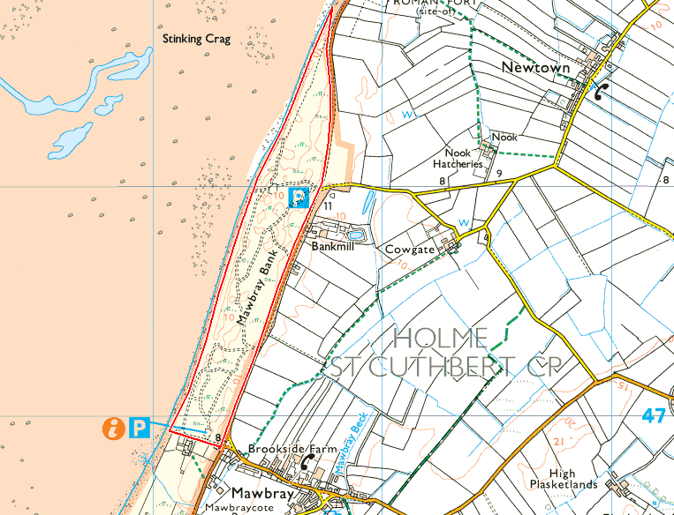
OS Map copied under licence (No. 100055725)

2. SURVEY METHOD

2.1 Field Survey
Each survey was carried out by Mike Douglas BSc MCIEEM, of South Lakes Ecology.
An initial site meeting with the site manager (14th May 2021) helped define the location of transects (see fig 2), the main determining factor being the completion of a representative survey of all habitats. These concentrate on the new cattle grazed area (7 transects with 60 quadrats) but also including a lesser number of transects within the ungrazed area to the north of this (3 transects with 20 quadrats). Some transects were also positioned deliberately to take in specific management interventions and features including Rosa rugosa scrapes and pond margins. Placement of individual quadrats along a transect was a subjective judgement by the surveyor. Good coverage of all habitats was the key factor in this decision, an additional guide being the potential effects of the newly introduced cattle. For this reason quadrats were sometimes placed on the edge of a vegetation community (eg. maritime heath), rather than well within a homogenous stand (the typical NVC approach to avoid edge effects) so that effects on these vegetation transitions could be measured by repeat surveys.

Fig 2, transects – red lines (numbered), quadrats- blue dots, fixed points- green dots
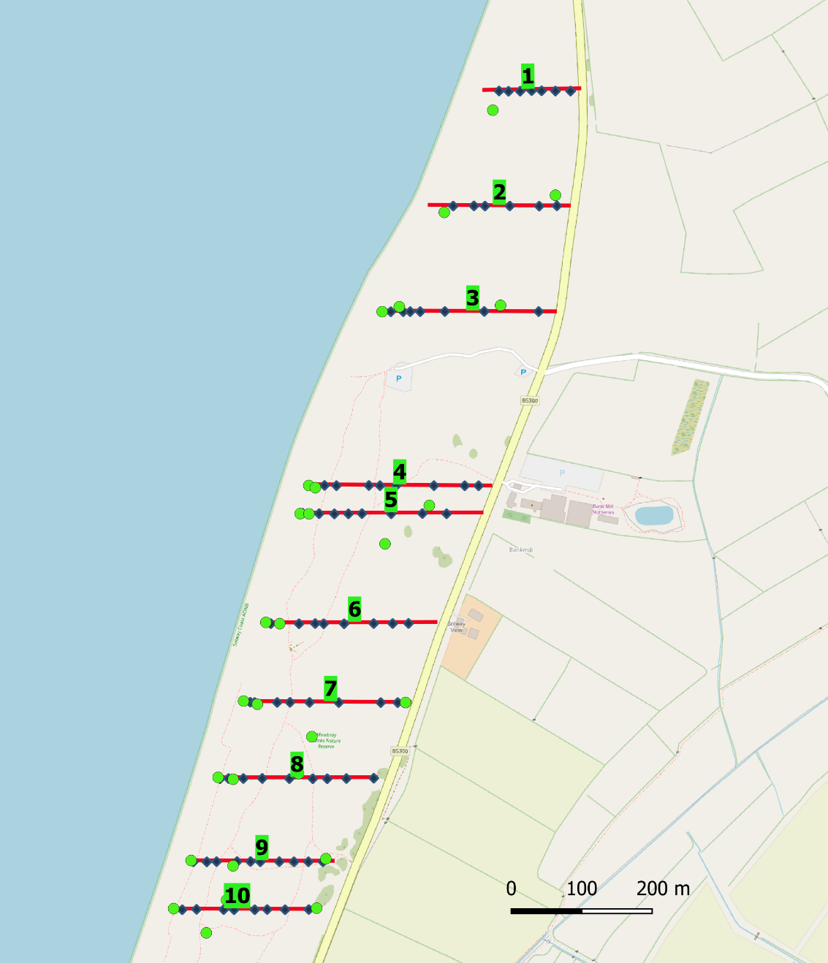
See Appendix 1 for more detailed map showng transects, quadrats and fixed point photos.

The more mobile vegetation communities of the sea front, to the west of the stock fence, were not sampled. A species list was compiled however, from a walk over within a 10m radius of the start of transects, and fixed point photography also covered these areas.
The south-west corner of each quadrat was located using handheld GPS, the ten-figure grid reference being recorded on the survey form and digitally. 2m x 2m quadrats were then set up using rope and pegs, the sides of the quadrat extending north and east from this initial point.
Within each quadrat all vegetation including higher plants and bryophytes were identified to species where possible, and each species was scored using the DOMIN cover scale (see Rodwell et al, 1991-2000) and the DAFOR scale (see table 1). Festuca ovina and Festuca rubra were one of the main exceptions to this rule, with identification only possible where numerous flowering spikes and adjacent vegetation were accessible. Even where this was the case and the presence of both species could be ascertained, vegetative cover of these two species could rarely be separated, so a combined total was given instead. Additional information gathered included slope, aspect, vegetation layers and their height and additional comments on stand structure and species immediately outside of quadrats. Nine vegetation heights were also recorded at specific points in the quadrat, by splitting the square into 12 equal squares, each measuring 0.5m x 0.5m, and measuring at each intersection of this grid (see figure 3). Measurements were of vegetative rather than flowering parts and were rounded to the nearest 5cm.
Figure 3, showing veg height measuring points.
2m
2m

Species identification was completed in the field where possible, with samples of more difficult species photographed or taken back to the office for microscopic identification or cross-referencing with additional texts. Scientific names of plants were generally aligned with those given in Rodwell (1991 – 2000) to aid community categorisation and cross referencing with these texts, but these were updated to those given in the BSBI complete taxon list (2007) to provide more clarity in species receiving complete name changes in the intervening period.
Photographs were taken of every quadrat and also from 28 fixed point locations.

2.2 Desktop NVC categorisation
Survey data was digitised and categorised in the office. It should be noted that NVC categorisation of a vegetation stand would typically rely on data from numerous quadrats within that stand, with resulting DOMIN ranges and constancy scores being applied to NVC keys in the relevant British Plant Communities Volume (Rodwell et al, 1991-2000), or through data being fed into software which can determine community identification. In this survey, most stands of vegetation held a single quadrat and categorisation was achieved through reference to NVC community descriptions and a working knowledge of coastal habitats. This should be considered when referring to NVC communities given in this document, and it will limit the inferences and later comparisons that can be made when looking at the NVC code in isolation. As Rodwell (2006) stated, the NVC is not a monitoring tool, and future comparisons should concentrate on species presence / absence, cover estimates and height and structural information ahead of perceived spatial changes in NVC communities.

2.3 Survey Constraints
There were few constraints in this survey due to optimal timing of surveys (18th June – 13th July) and due to limited grazing of vegetation at Mawbray at this time. This meant that key identification features were visible on a wide variety of plants. Species which developed or flowered earlier than these dates may have been under-recorded however (i.e. Luzula spp, Vicia lathyroides)

3.0 SURVEY RESULTS
Table 1, Quadrats falling into NVC Communities

Trans | SD7c Ammophila – Festuca, Ononis sc | SD8a Festuca – Galium verum, typ sc |  | SD8b Festuca – Galium verum, Luzula sc | SD9a Ammophila– Arrhenatherum, typ sc | SD12a Carex arenaria–Festuca-Agrostis, Anthoxanthum sc | SD12b Carex arenaria–Festuca-Agrostis, Holcus sc | H11a Calluna vulgaris-Carex arenaria, Erica sc | H11c Calluna vulgaris-Carex arenaria, spp poor sc | M23a Juncus acutiflorus-Galium palustre,  J.acutiflorus sc | MG1 Arrhenatherum grassland
1 |  | 74, 76 |  |  | 75 | 77, 79 |  |  |  |  | 80
2 |  |  |  | 68 |  | 71, 72
3 |  | 62 |  | 63 | 61 | 67 |  | 66 | 65 |  | 64
4 |  | 53, 54 |  |  | 58, 59, 60 | 56, 57 | 55
5 | 44 |  |  | 45, 47 | 46 | 48 | 51 |  |  | 49
6 | 36 | 37 |  | 39 | 41, 42 | 38, 40 | 43
7 |  | 31 |  |  | 29, 30, 35 | 32 | 34 |  | 33
8 | 19 | 22 |  |  | 20, 21, 25, 26 |  |  |  | 24
9 |  | 9, 15 |  | 11, 17 | 10, 12 |  | 14 |  | 18
10 |  | 3, |  |  | 2, 8 |  |  |  | 5, 6
None categorised quadrats |  |  | 1, 13, 23, 28, 52
Transitional vegetation |  |  | 4, 7, 16, 27, 50, 69, 70, 73, 78

See Appendix 3 (separate document) for all raw data.

Table 2, Species recorded at the seaward end of each transect
 | Transect number
Species | 1 | 2 | 3 | 4 | 5 | 6 | 7 | 8 | 9 | 10
Leymus arenarius
Elymus farctus
Elymus pycnanthus
Honkenya peploides
Cakile maritima
Eryngium maritimum
Orache spp
Raphanus raphanistrum
Coincya monensis
Vicia hirsuta
Vicia cracca
Lotus corniculatus
Hypochoeris radicata
Ononis repens
Sonchus arvense
Tripleurospermum maritimum
Valeriana officinalis
Angelica sylvestris
Rosa rugosa
Rumex crispus
Torilis japonica
Cirsium vulgare

NB. Species common immediately inland such as Ammophila arenaria and Festuca rubra were not recorded in the above lists. A separate list was not created for the start of transect 1.
Fixed point photographs, taken at the western end of each transect and at other prominent locations are listed in Appendix 2.

3.1 Summary of results
The study of numerous quadrats along west to east transects at Mawbray has revealed a broken but consistent pattern of vegetation change from west to east across the SSSI, and also shows the all-pervading threat of nutrient enrichment and succession that recent management changes hope to reverse.
The vegetation of western quadrats is heavily influenced by the proximity of the sea and wind-blown sand, which results in base enrichment of these areas and in some places, recently deposited, bare sand which provides opportunities for early colonisers to establish. Many western quadrats therefore hold SD7 (semi-fixed dune) or more often, SD8 (diverse, fixed dune) communities with numerous herbs and in the case of the latter, generally short swards, a combination which favours invertebrates and amphibians such as natterjack toad. Common features of the SD8 vegetation at this site include the dominance of Festuca rubra over Festuca ovina, a lack of acidophile mosses which are found further to the east (see below) and a relatively high cover of flowering herbs. This latter feature was less pronounced than seen at other sand dune sites however, due to a lack of grazing which has shifted the vegetation to a less diverse, more grass dominated sward. Tall Arrhenatherum elatius was present in many SD8 quadrats signifying and exacerbating this shift to lower diversity. Patches of richer SD8 vegetation were still present throughout however, as seen in the more diverse SD8b community in quadrats 11, 17, 39, 45, 47, 63 and 68.

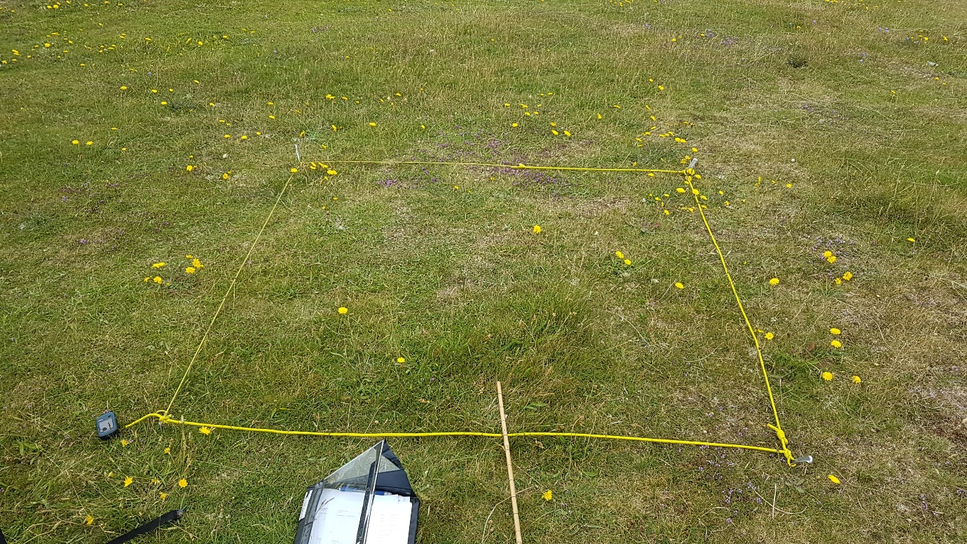
Image 1, Quadrat 68, with relatively high proportion of Thymus praecox, Lotus corniculatus, Hypochoeris radicata, Luzula campestris and Koeleria macrantha

Moving east away from this coastal influence, substrates become leached and therefore more acid, resulting in a change to SD12 dune grassland, typically illustrated by increasing cover of Festuca ovina, Agrostis capillaris, and acidophile mosses such as Pleurozium schreberi and Hylocomnium splendens alongside the constant presence of Carex arenaria. Many of the Mawbray quadrats holding this vegetation were species poor, with Galium saxatile or Rumex acetosella sometimes the only herbs in a grass, sedge and moss dominated sward, but more herbs should be expected in this community with an increase in grazing including Thymus praecox, Lotus corniculatus, Campanula rotundifolia and Jasione montana.
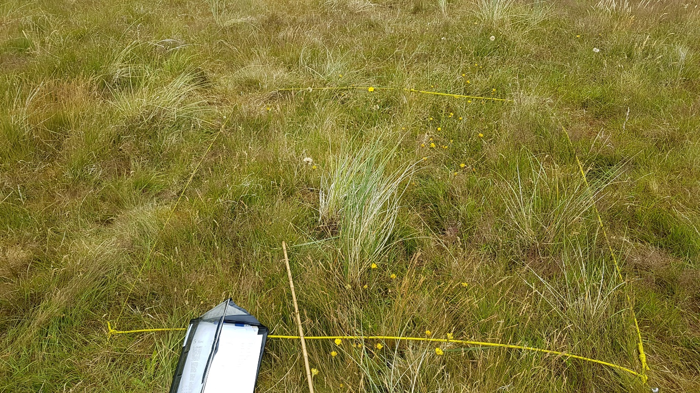
Image 2, Quadrat 57 showing grass and moss dominated SD12 vegetation with relatively low cover of herbs (Hypochoeris radicata, Galium saxatile and Conopodium majus

Much of the SD12 vegetation is further limited in its diversity due to the spread of Arrhenatherum elatius, and many quadrats (16, 50, 73 and 78) seem to be in transition between SD12 and Arrhenatherum dominated communities (SD9 and MG1).

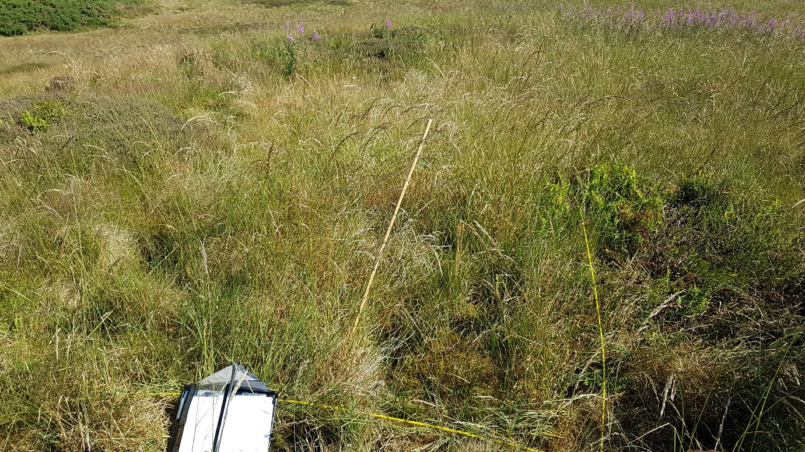
Image 3, Quadrat 73, holding many acidophile species of the SD12 community, now dominated by Arrhenatherum elatius

Also more common away from the western coastal strip is the H11 Calluna vulgaris – Carex arenaria vegetation, which is often intimately mixed with the grassier patches of the SD12 community. Most is of the species-poor sub-community but there is a bigger contribution from Erica cinerea to the north as illustrated by quadrat 66. Once again, it seems to be under threat from the spread of Arrhenatherum elatius with the worst evidence of this seen at quadrat 27 (eastern extreme of quadrat 8).

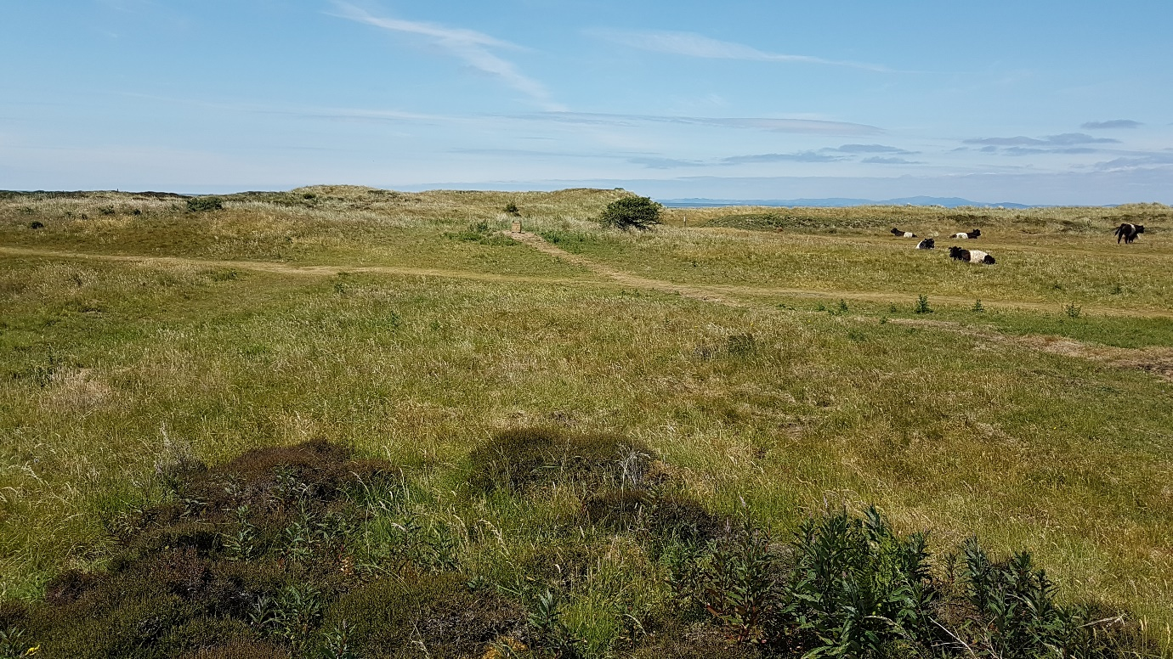
Image 4, H11 heath and SD12 grassland in the foreground, with more Marram dominated vegetation to the west, all showing flowering heads of Arrhenatherum elatius
While the spread and dominance of Arrhenatherum and its negative effects on diversity are of concern at Mawbray, this survey shows that the full suite of expected coastal plant communities are at least present throughout the site and have a near full complement of constituent species which can spread as conditions improve. Further encouragement is given by the observations of cattle immediately targeting Arrhenatherum over other species soon after their introduction.

References:
Rodwell, J.S., Pigott, C.D., Ratcliffe, D.A., Maloch, A.J.C., Birks, H.J.B., Proctor, M.C.F., Shimwell, D.W., Huntley, J.P., Radford, E., Wiggington, M.J., Wilkins, P. (1991) ‘British Plant Communities, Volume 1, Woodlands and Scrub,’Cambridge University Press
Rodwell, J.S., Pigott, C.D., Ratcliffe, D.A., Maloch, A.J.C., Birks, H.J.B., Proctor, M.C.F., Shimwell, D.W., Huntley, J.P., Radford, E., Wiggington, M.J., Wilkins, P. (1991) ‘British Plant Communities, Volume 2, Mires and Heaths,’ Cambridge University Press.
Rodwell, J.S., Pigott, C.D., Ratcliffe, D.A., Maloch, A.J.C., Birks, H.J.B., Proctor, M.C.F., Shimwell, D.W., Huntley, J.P., Radford, E., Wiggington, M.J., Wilkins, P. (1991) ‘British Plant Communities, Volume 3, Grasslands and Montane Communities,’ Cambridge University Press.
Rodwell, J.S., Pigott, C.D., Ratcliffe, D.A., Maloch, A.J.C., Birks, H.J.B., Proctor, M.C.F., Shimwell, D.W., Huntley, J.P., Radford, E., Wiggington, M.J., Wilkins, P. (1995) ‘British Plant Communities, Volume 4, Aquatic communities, swamps and tall-herb fens,’ Cambridge University Press.
Rodwell, J.S., Pigott, C.D., Ratcliffe, D.A., Maloch, A.J.C., Birks, H.J.B., Proctor, M.C.F., Shimwell, D.W., Huntley, J.P., Radford, E., Wiggington, M.J., Wilkins, P. (2000) ‘British Plant Communities, Volume 5, Maritime communities and vegetation of open habitats,’ Cambridge University Press.
BSBI (2007), ‘Short list of accepted plant names.’ https://bsbi.org/taxon-lists
Rodwell, J.S. (2006). ‘NVC users handbook,’ JNCC.

Bibliography:
Rose , F. updated by O’Reilly, C. (2006), ‘The Wildflower Key,’ Penguin Group
Gerrard, I, Streeter, D. (1998), ‘The wild flowers of the British Isles,’ Midsummer Books Ltd
Fitter, R, Fitter, A and Farrer, A, (1984), ‘Grasses, sedges, rushes and ferns of Britain and Northern Europe,’ Harper Collins Publishers.
Cope, T. Gray, A. (2009), ‘Grasses of the British Isles,’ BSBI
Rose, F. (1989), ‘Grasses, sedges, rushes and ferns of the British Isles and north-western Europe,’ Penguin Books Ltd.
Stace, C. (1999), ‘Field Flora of the British Isles,’ Cambridge University Press

Appendix 1a, Mawbray north, quadrat (blue diamonds) and fixed point photo locations (green dots, pink background to numbers) and transect numbers (green background to numbers).
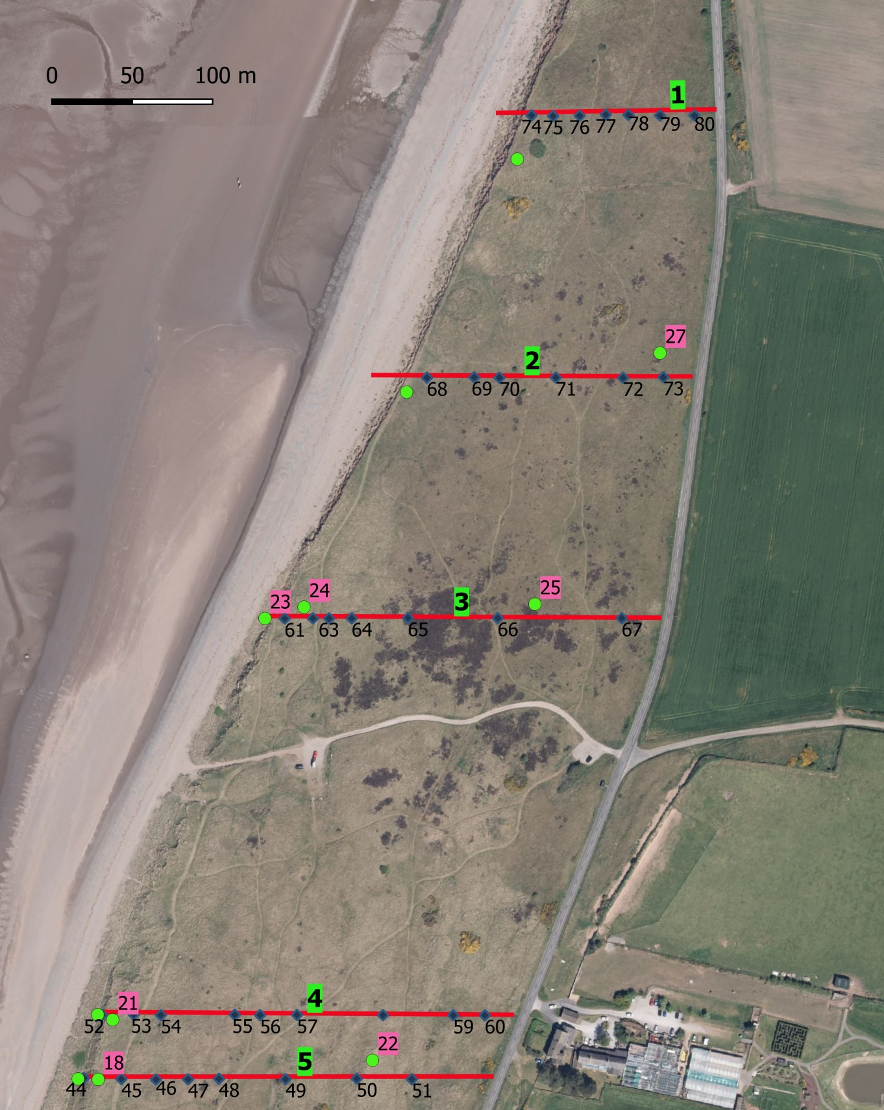
Background tile – Bing Maps, date not given

Appendix 1b, Mawbray south, quadrat (blue diamonds) and fixed point photo locations (green dots, pink background to numbers) and transect numbers (green background to numbers).
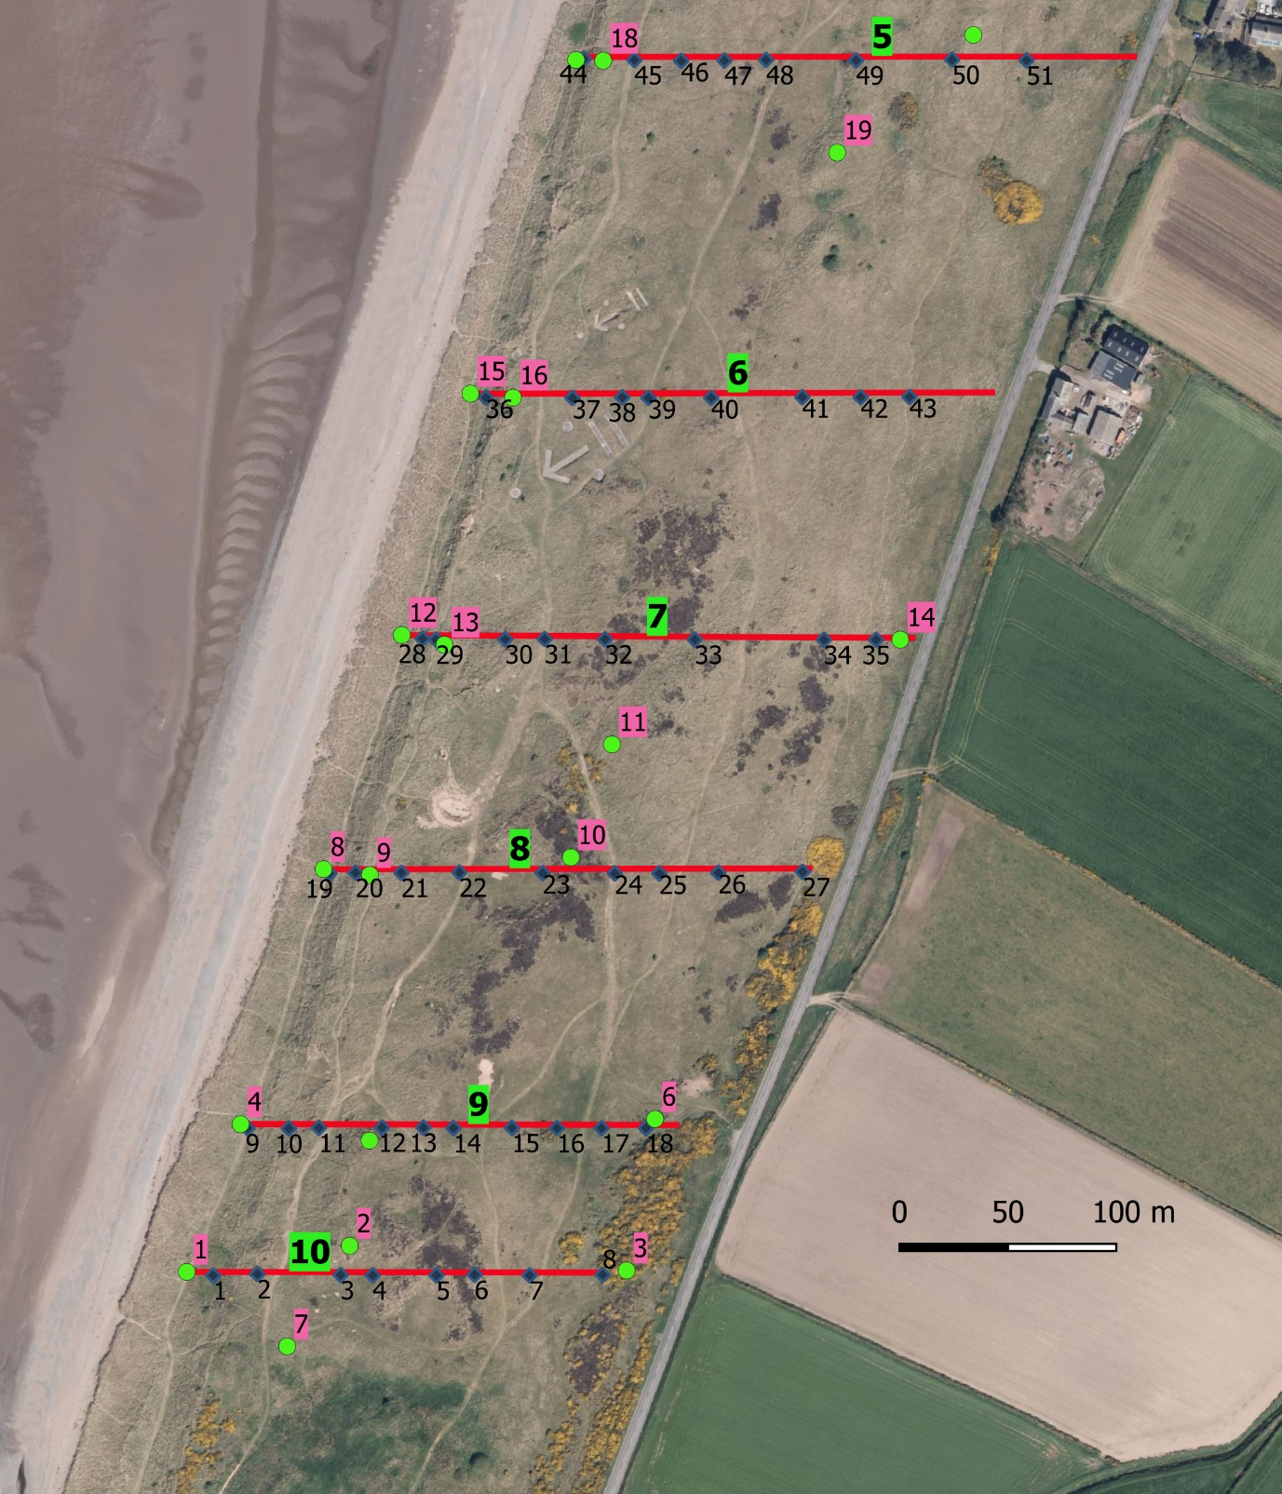
Background tile – Bing Maps, date not given

Appendix 2, Fixed point photograph locations and directions

 |  |  | Compass angle
id | Eastings | Northings | Direc 1 | Direc 2 | Direct 3 | Direc 4
1 | 308203 | 547229 | 0 | 90 | 180 | 270
2 | 308278 | 547241 | 0 | 90 | 180 | 270
3 | 308406 | 547229 | 0 | 90 | 180 | 270
4 | 308228 | 547297 | 0 | 90 | 180 | 270
5 | 308288 | 547289 | 0 | 90 | 180 | 270
6 | 308419 | 547299 | 0 | 90 | 180 | 270
7 | 308250 | 547194 | 90 | 0 | 0 | 0
8 | 308266 | 547415 | 0 | 90 | 180 | 270
9 | 308288 | 547412 | 0 | 90 | 180 | 270
10 | 308380 | 547420 | 0 | 90 | 180 | 270
11 | 308399 | 547473 | 200 | 260 | 290 | 347
12 | 308302 | 547523 | 0 | 90 | 180 | 270
13 | 308322 | 547519 | 0 | 90 | 180 | 270
14 | 308532 | 547521 | 0 | 180 | 270 | 0
15 | 308334 | 547635 | 0 | 90 | 180 | 270
16 | 308354 | 547633 | 0 | 90 | 180 | 270
17 | 308383 | 547789 | 0 | 90 | 180 | 270
18 | 308395 | 547789 | 0 | 90 | 180 | 270
19 | 308503 | 547747 | 0 | 90 | 180 | 270
20 | 308395 | 547829 | 0 | 90 | 180 | 270
21 | 308404 | 547826 | 0 | 90 | 180 | 270
22 | 308566 | 547801 | 0 | 90 | 180 | 270
23 | 308499 | 548076 | 24 | 204 | 0 | 0
24 | 308523 | 548083 | 0 | 90 | 180 | 270
25 | 308667 | 548085 | 0 | 90 | 180 | 270
26 | 308587 | 548217 | 0 | 90 | 180 | 270
27 | 308745 | 548241 | 0 | 90 | 180 | 270
28 | 308656 | 548362 | 20 | 110 | 200 | 290

